**PROJECT REPORT**

**ST.JOHN’S COLLEGE _ PALAYAMKOTTAI**

**DEPARTMENT OF PHYSICS**

**ANALYZING THE PERFORMANCE & EFFICIENCY OF THE RADISSON HOTEL USING DATA VISUALIZATION TECHNIQUES**

**TEAM MEMBERS**

**P.DIVIN**

**M.BARATH**

**PRAWIN RAJA**

**MARI SHANMUGAM**

**ANALYZING THE PERFORMANCE & EFFICIENCY OF THE RADISSON HOTEL USING DATA VISUALIZATION TECHNIQUES**

**INTRODUCTION:**

**PROJECT DESCRIPTION:**

**The hotel industry is a broad category of businesses that provide lodging service for traveler and tourists .This can include a wide range of establishment from luxury resort to budget-friendly motels as well as extended stay hotels ,boutique hotel, and more .Hotels can be found in nearly every corner of the world, and are often major component of the tourism and travel industry in a given area.**

**OVERVIEW:**

**Radisson owns multiple five –star hotels across India .They have been in the hospitality industry for the past 100 years .Due to strategic moves from other competitor and ineffective decision-making in management, Radisson is losing its market share and revenue in the luxury/business hotel category. As a strategic move , the managing director of Radisson wanted to incorporate Business and Data intelligence in order to regain their market share and revenue . Our task is to create an analytics dashboard& story to provide them insight to make better decision.**

**PURPOSE:**

**The purpose of this Analysis is to improve the profit level of the Radisson hotel .And to regain their share and revenue of their hotels. And improve the source of income in various categories.**

**PROBLEM DEFINITION &DESIGN THINKING:**

**EMPATHY MAP**

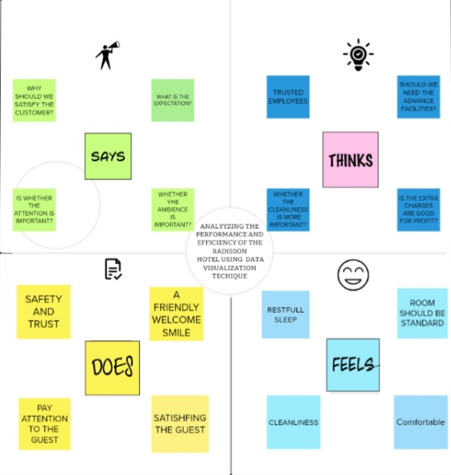

**IDEATION & BRAINSTORMING MAP:**

## BRAINSTORMING.

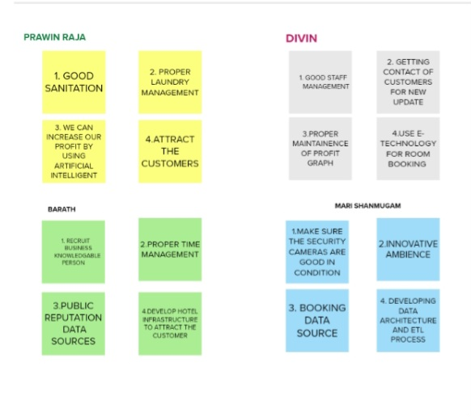

# RESULT: C:\Users\hp\Downloads\RADISSON HOSPITALITY ANALYSIS.png

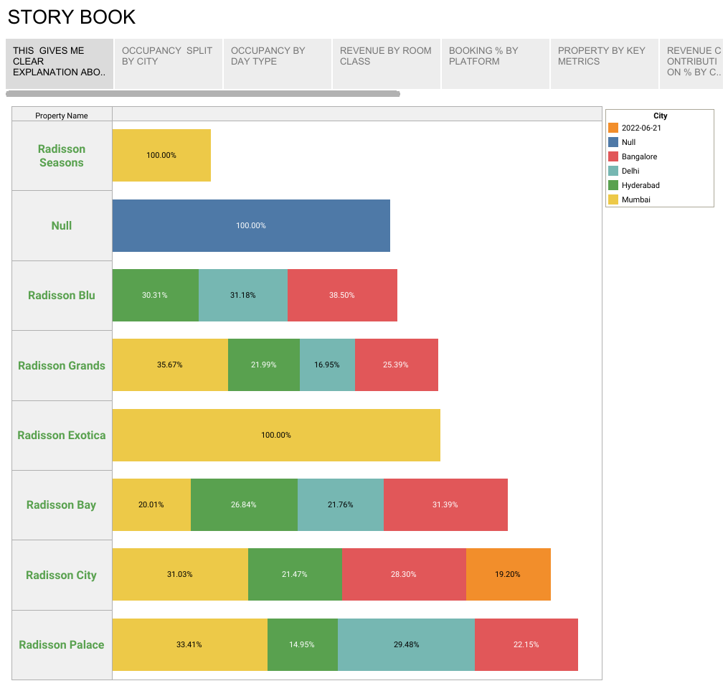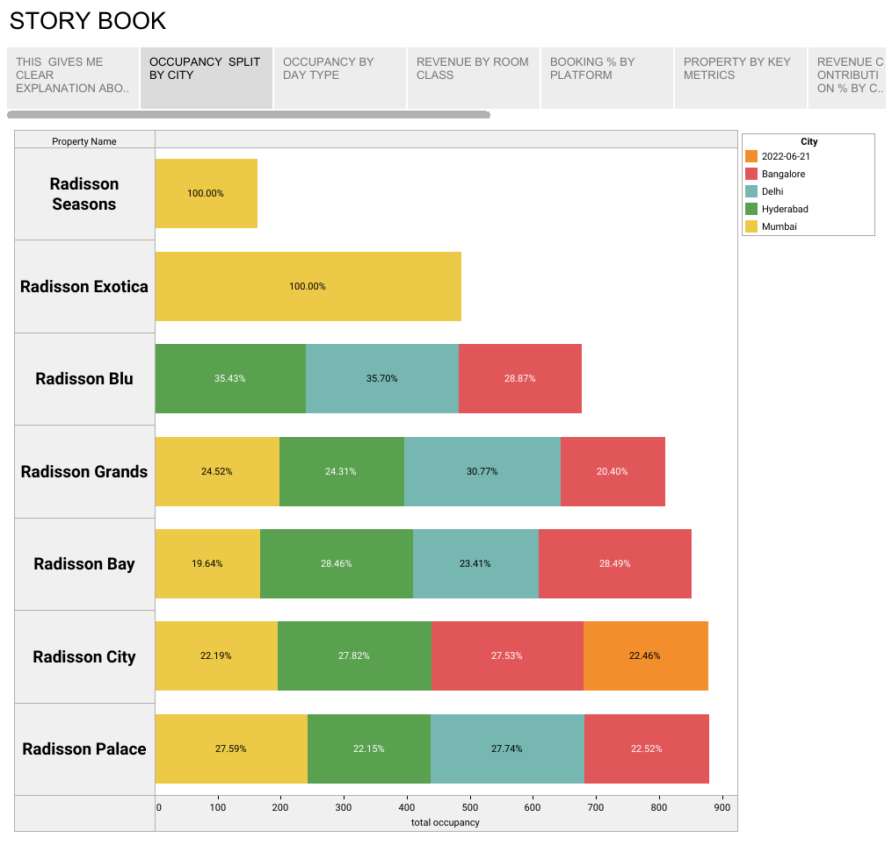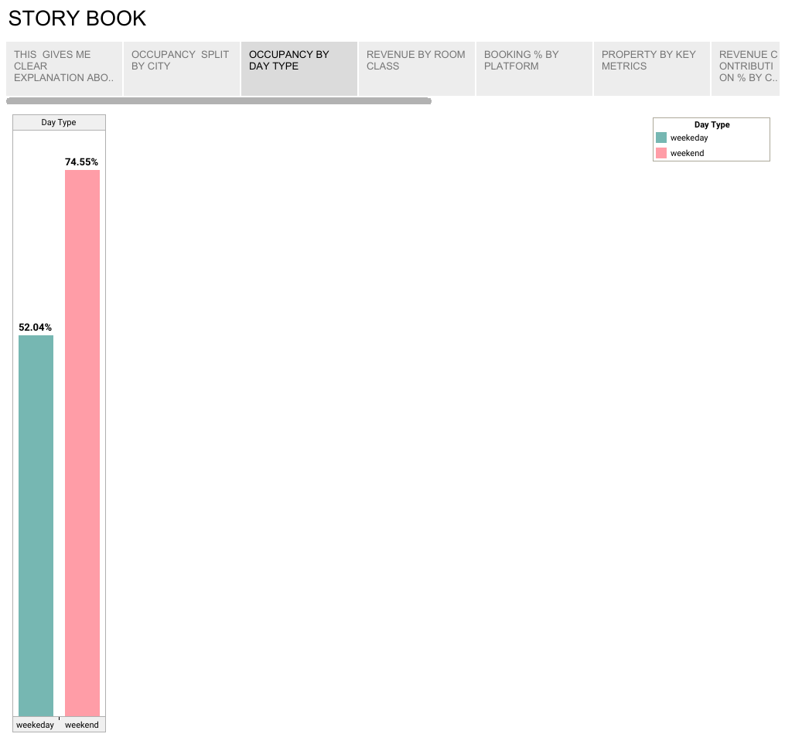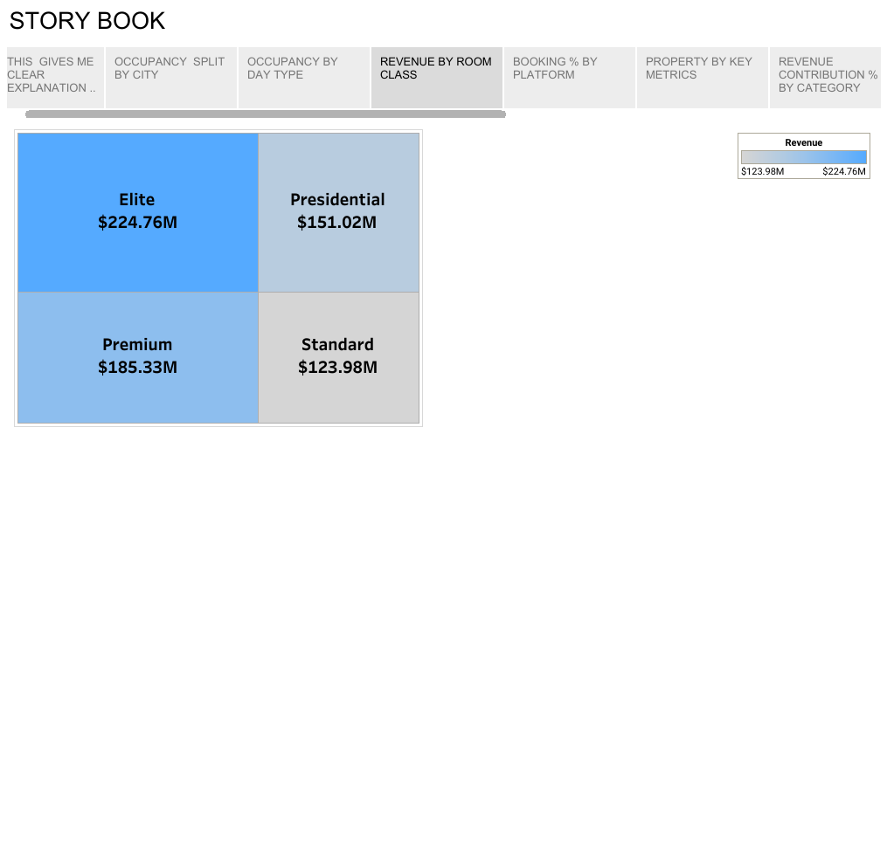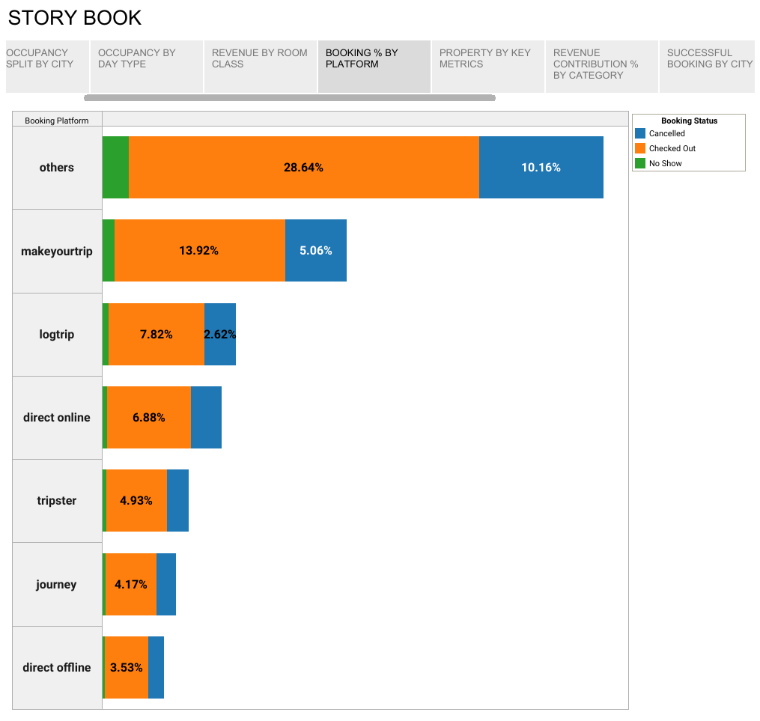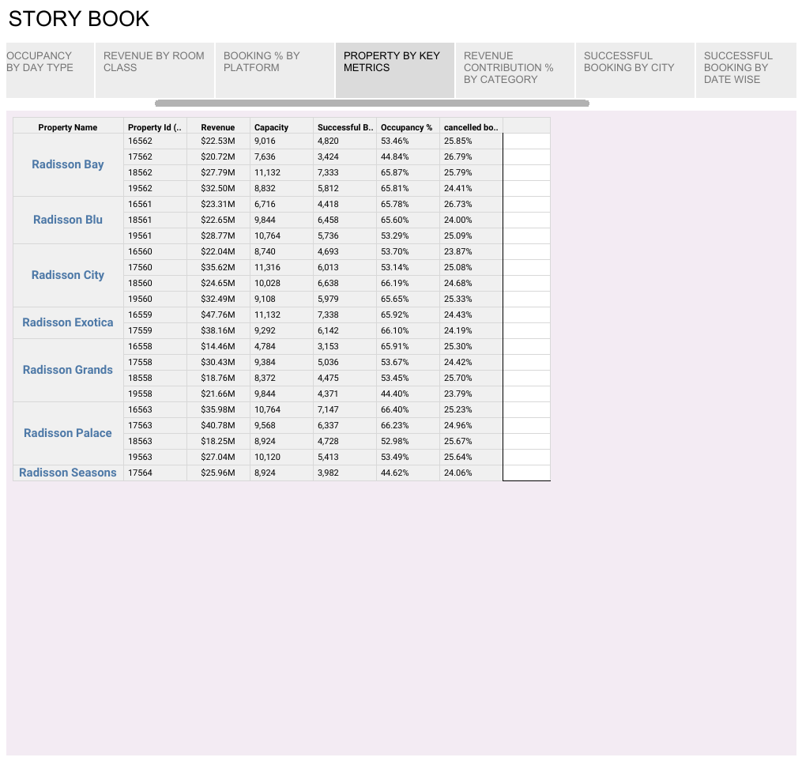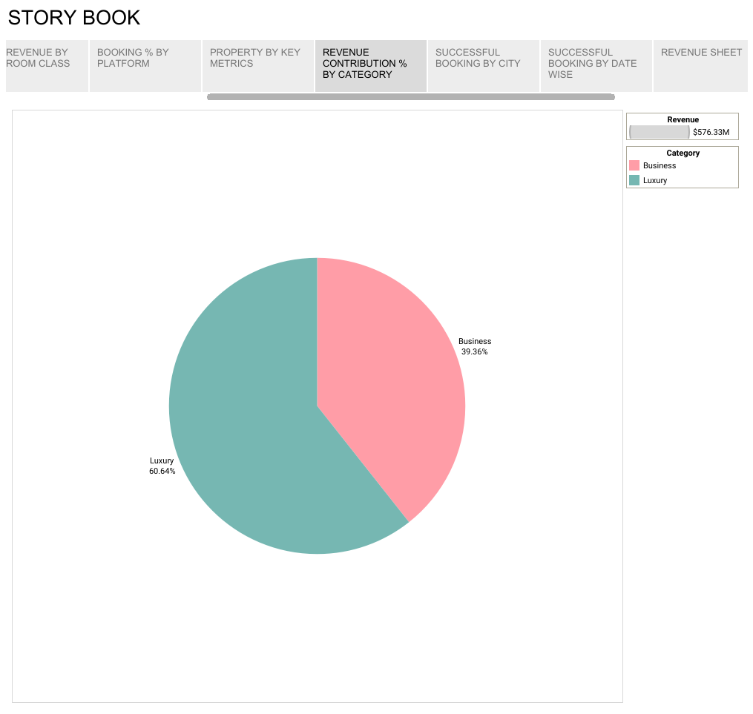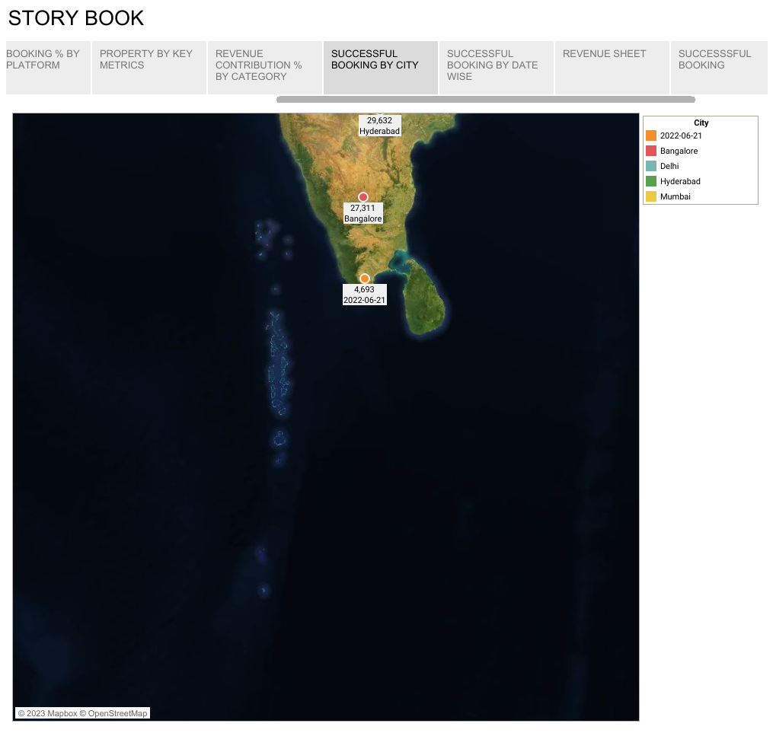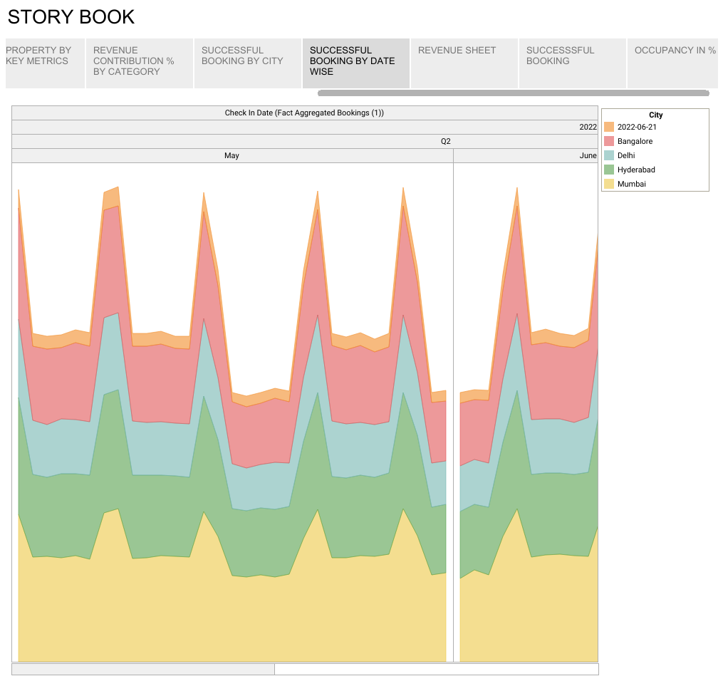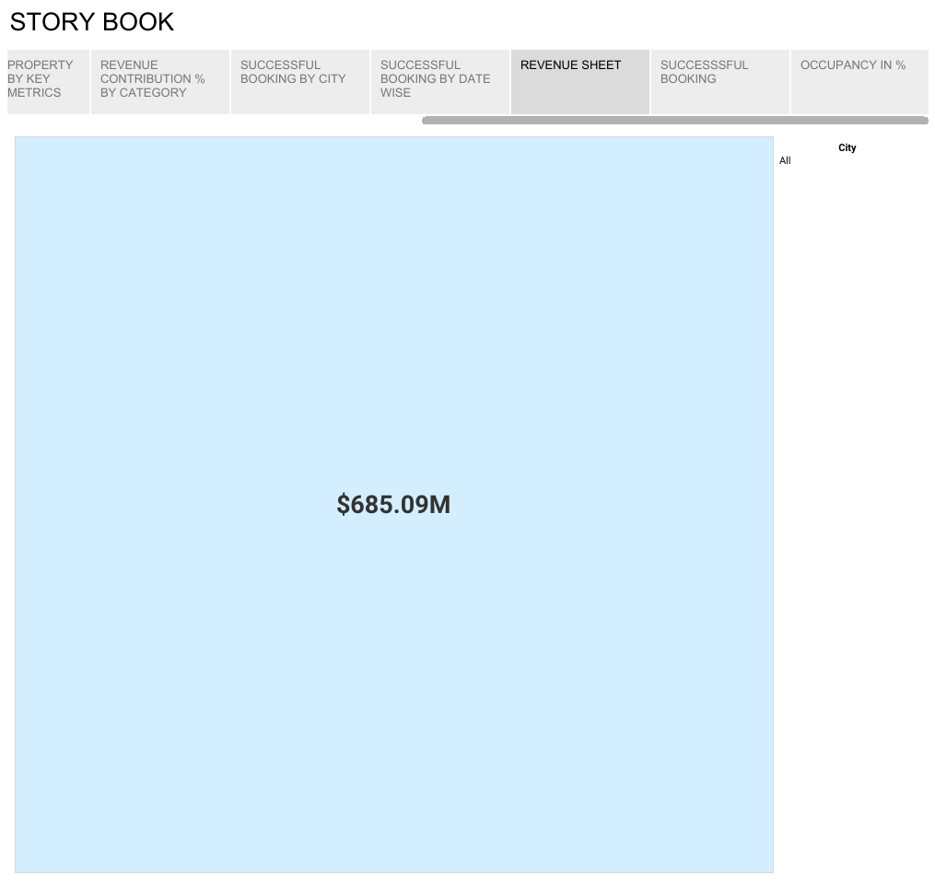

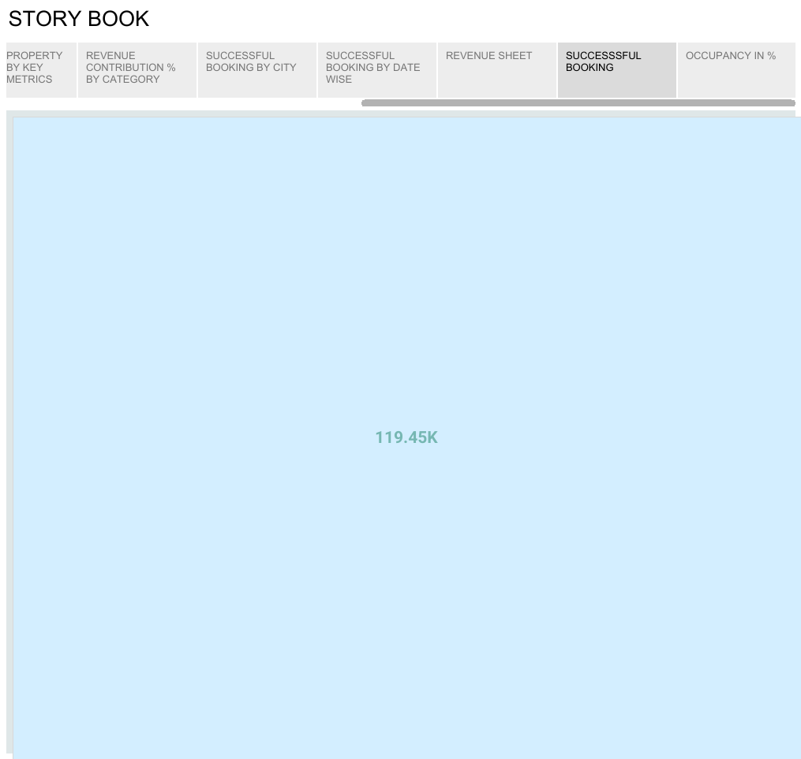

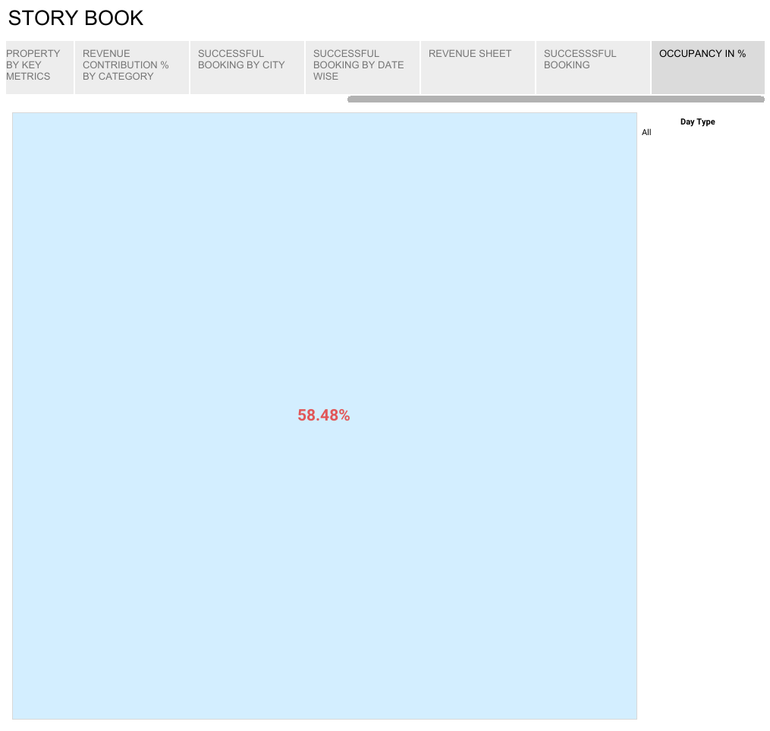

ADVANTAGE

* The working environment of hotel industry is very good compare to other industry.
* If you have Hospitality degree you can find job anywhere. Like Airline Catering, Cruise ship etc.
* This is the fastest growing industry.

DISADVANTAGE

* You can see other jobs time to time but hospitality not. If you become chef there is long Shifting hours like above 12 hours.
* This industry gives you lots of stress. If you are at managerial level then stress of your company growth.
* In hotel Industry Initial salary is very low compare to others.

APPLICATIONS

* **Lighting -**It offers options of lighting such as choices for switching between colors, shifting colors and modifying hue and light temperature.
* **Room Temperature -**Using smart thermostats permits guests to ensure their rooms are comfortable while avoiding the inconvenience of out of date window A/C units.
* **Adjusting windows -** The automated window treatments offer complete control to guests merely by pressing a button or through use of applications.

CONCLUSION

Hotel management system now-a-day have the advantage of modernization. .Computer have done the work more easy. Computer is playing a important role in management. Hotel management system has also primary purpose is to provide facilities to customers.

FUTURE SCOPE:

Radisson hotel group is, one of the world’s leading hotel groups, has received confirmation and validation of its near-term Science Based Targets (SBTs) aligned with its commitment to be Net – Zero by 2050.

APPENDIX

SOURCE CODE:

file:///C:/Users/hp/Desktop/Divin/Radisson%20Hotels%20Analysis%20using%20Visualization%20Techniques/templates/index.html